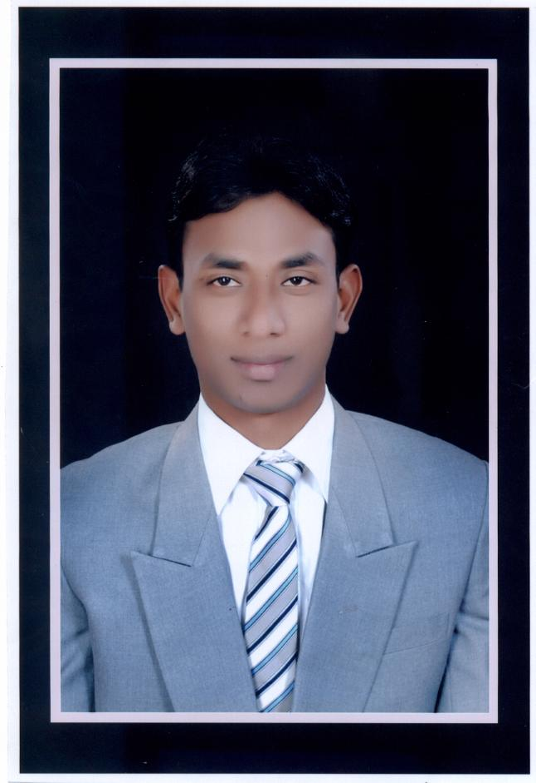
CURRICULAM VITAE

Name: MD SHABBIR ANSARI

Date of Birth : - 12th January 1991
Present Address : - VILLAGE - BHAKHARA,
P.O- HANSADIH
,P.S- MASAURHI
District- PATNA
, PIN CODE- 804452 (BIHAR)
Nationality :- INDIAN
E-mail Id :- shabbirdear2015@gmail.com
Mobile :- + 918863988929
Father :- MD SHAMIM ANSARI

CARREER OBJECTIVES

To work in a progressive organization that incorporates varied spectrums of work & diversity, this endows consistency, competency & expertise in professional as well as social spheres, enabling collective excellence and technical growth, personal fulfillment with welcome attitude for new ideas and concepts to enhance the overall growth of the organization.

EDUCATIONAL QUALIFICATION

Year of  Passing | Exam Passed | University / Boards | Institution | Percentage
2014 | MBA  (FINANCE) | SIKKIM MANIPAL UNIVERSITY | CYBOTEACH CAMPUS | C grade
2012 | BBA | MAULAMA MAZAHARUL HAQUE UNVERSITY | BIHAR URDU ACADEMY | 74%
2009 | ISC | BIHAR SCHOOL EXAMINATION BOARD | DR. ZAKIR HUSSAIN HIGH SCHOOL +2 | 64%
2005 | MATRIC | BIHAR SCHOOL EXAMINATION BOARD | ADARSH HIGH SCHOOL PALANGA | 55%

WORK EXPIRIENCE / INDUSTRY EXPOSURE / SUMMER INTERNSHIPS

- Presently Working in Passport Seva Kendra Appointed through TATA CONSULTANCY SERVICE(TCS) Head Quarter ,KOLKATA
- DESIGNATION-- CUSTOMER SERVICE EXECUTIVE
FUNCTION-( ITES) The role is to verify the documents of the applicant who have applied for the passport application and proceeding the applicant to the next Higher Officer for the further processing.
LOCATION-- PASSPORT SEWA KENDRA PATNA
COMPANY – TCS TATA CONSULTANCY SERVICE.

NAME OF COMPANY | POSITION | PERIOD
TCS- Tata Consultancy Services Limited. | CSE Customer Service Executive | 14/07/2014 to Till date

PASSPORT DETAILS

- Passport Number : L 4690256
- Date of Issue : 20.09.2013
- Date of Expiry : 19.09.2023
- Place of Issue : PATNA

DECLARATION :

I hereby declare that made above statement are true and correct to the best of my knowledge & belief.

Thanking you,

